Product Requirements Document (PRD): N8N Sales AI Agent

1. Executive Summary & Objective
The core objective of this project is to develop a fully automated, intelligent Sales AI Agent utilizing N8N as the central orchestration engine. This agent will integrate seamlessly with the WhatsApp Business API to interact with prospects and customers. Its primary function is to ingest predefined OKRs (Objectives and Key Results) and KPIs from the management team, intelligently steer the conversation to meet these strategic targets, persuasively negotiate with the customer, perform automated follow-ups, and notify the human sales team immediately once the customer is convinced and ready to sign the contract.

2. Target Audience & User Personas
- The Customer (End-User): Seeking services or products, prefers quick, asynchronous, and natural communication via WhatsApp. Expects personalized and immediate responses.
- The Sales Manager (Admin/Stakeholder): Sets the strategic OKRs and KPIs (e.g., minimum margin, focus products) that dictate the AI Agent's negotiation boundaries and overarching goals.
- The Human Sales Representative: Steps in exclusively at the final stage to close the deal, prepare the paperwork, and sign the contract after the AI has successfully completed the lead nurturing and negotiation phases.

3. Product Features & Requirements

3.1 WhatsApp Business API Integration via N8N
- Requirement: Establish a robust, bi-directional communication channel between the N8N workflow and the WhatsApp Business API.
- Details: Utilize N8N Webhook nodes to receive incoming user messages, status updates, and read receipts in real-time. Use HTTP Request nodes to send text, documents, and interactive message templates back to the customer.

3.2 OKRs & KPIs Ingestion & Routing System
- Requirement: A dynamic mechanism to feed business objectives into the AI's core negotiation logic.
- Details: Managers can input specific targets (e.g., "Push for an annual subscription over monthly", "Do not offer more than a 10% discount"). N8N will fetch these variables from a database or spreadsheet and dynamically inject them into the LLM's system prompt to constrain and guide the AI's responses.

3.3 AI Persuasion & Negotiation Engine
- Requirement: An LLM-powered cognitive engine capable of natural conversation, complex objection handling, and persuasive negotiation based on the ingested OKRs.
- Details:
  - Integration with LLMs (e.g., Gemma 4, Qwen 2.7, or Gemini 1.5 Pro) via N8N specialized nodes.
  - Maintain a continuous conversation history (Memory Component) per user phone number to ensure context continuity across multiple days.
  - Implement semantic routing to identify customer intent (e.g., asking a question, raising an objection regarding price, or agreeing to terms).

3.4 Automated Follow-Up System
- Requirement: Prevent lead drop-off by automatically reaching out to unresponsive leads at strategic intervals.
- Details: Utilize N8N 'Wait' nodes or scheduled Cron triggers. If a user does not reply within a specified timeframe (e.g., 24 hours), the system will trigger the LLM to generate a context-aware, polite follow-up message designed to re-engage the prospect without being overly aggressive.

3.5 Deal Closure & Hand-off Notification System
- Requirement: Alert the human team exactly when the AI successfully secures a verbal or textual agreement from the customer.
- Details: Once the intent classifier detects "Ready to Sign", "Agreed", or "Send the contract", N8N will immediately pause the AI's direct responses and trigger a critical alert (via Whatsapp, Email, and internal CRM/Dashboards). This alert will contain a concise summary of the negotiation, the agreed-upon terms, and a direct link to the customer's contact details.

4. System Architecture & Data Flow
The standard operational workflow in N8N will follow this sequence:
- Trigger: Customer sends a WhatsApp message. N8N Webhook captures the JSON payload.
- Pre-processing: Retrieve the user's profile and historical chat logs from the operational database (e.g., PostgreSQL).
- Context Injection: Fetch the current organizational OKRs & KPIs and append them to the LLM System Prompt.
- AI Processing: Transmit the aggregated payload to the LLM API to generate a persuasive, goal-oriented response.
- Intent Action: Evaluate the LLM's output intent. If "Deal Closed", trigger notification to the Sales Team. If "Normal Chat", send the generated response via the WhatsApp API.
- Wait State: Initiate a wait timer for potential automated follow-up if no subsequent reply is received.

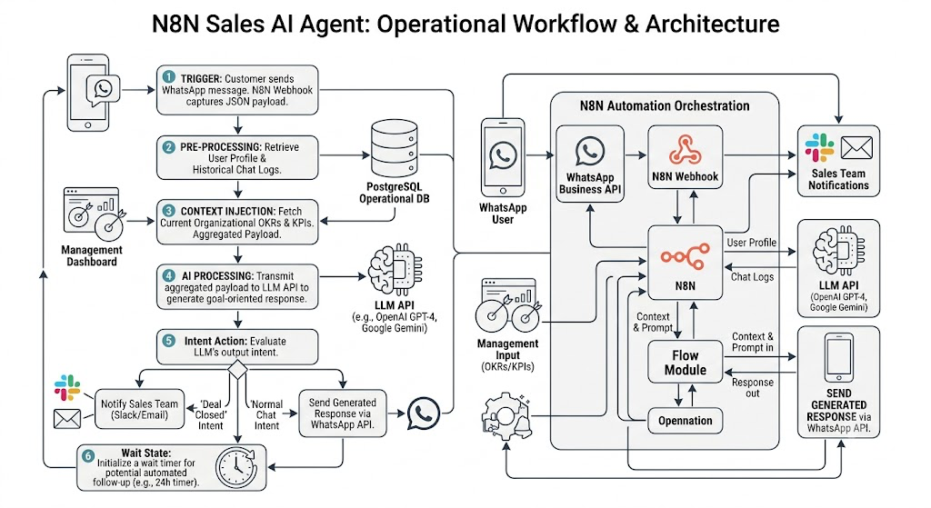

5. Non-Functional Requirements
Requirement | Description
Latency & Performance | The system must process the incoming webhook, query the LLM, and dispatch the WhatsApp response within 3-5 seconds to maintain a natural conversational flow.
Availability & Scalability | The N8N instance must maintain 99.9% uptime. It must be configured to handle concurrent webhook executions during high-volume marketing campaigns.
Security & Privacy | Sensitive Personally Identifiable Information (PII) must be handled securely and, where possible, masked before being sent to external LLM providers.

6. Success Metrics (KPIs for the AI Agent)
- Lead Conversion Rate: The percentage of total AI-managed conversations that result in a "Ready to Sign" handover.
- Average Handling Time: The duration from the initial lead interaction to successful deal closure.
- Follow-up Revival Rate: The percentage of previously unresponsive conversations successfully re-engaged by the automated follow-up system.
- Human Intervention Rate: The frequency at which human agents need to manually interrupt the AI due to errors or complex unhandled queries (Target: minimize).

7. Implementation Status & Executive Decision Addendum
Decision status: Synthetic-local implementation is complete and verified as of 15 July 2026. Production launch is not authorized.
Authority note: This addendum supersedes conflicting implementation assumptions in the original concept note. The assistant is policy-bound; it does not autonomously negotiate binding terms or declare a deal closed.

7.1 Delivered Synthetic-Local Baseline
? Seven native-node N8N workflows cover authenticated ingress, conversation orchestration, outbound dispatch, provider status, UTC Follow-Up scheduling, Handoff dispatch, and operations.
? PostgreSQL owns account-scoped business state, consent, Conversation ordering, policy/configuration versions, authorization, idempotency, retries, leases/claims, Handoffs, audit evidence, deletion minimization, and release activation.
? Ten typed JSON contracts define the synthetic-local account, Product Knowledge, Sales Policy, model, qualification, consent/templates, retry, Handoff, retention, and Release Set inputs.
? A one-command harness provisions disposable credentials, applies the migration twice, imports and publishes all workflows, executes runtime and concurrency checks, verifies canonical export identity and secrets hygiene, and cleans generated plaintext and Docker volumes.

7.2 Corrected Product and Authority Boundary
? The LLM may draft language and propose typed intent; deterministic Sales Policy and human approval control price, discount, scope, SLA, warranty, contract terms, and other commercial commitments.
? Customer buying intent produces ready_for_handoff. Only an authorized human or CRM may record approval or closed_won.
? A customer may request a human at any stage. Human-Owned blocks automated replies and Follow-Ups; opt-out suppresses every pending customer-facing action.
? Follow-Ups use durable UTC jobs and recheck consent, opt-out, ownership, timing, frequency, campaign state, and WhatsApp template eligibility immediately before send.
? Internal Contact and Conversation IDs own scope and history; a phone number is a channel identifier, not sole identity authority.

7.3 Verification and Evidence Boundary
Area | Current evidence | Executive meaning
Local runtime | N8N 2.30.4 and PostgreSQL 17.10, digest-pinned | Reproducible local baseline
Behavior | PASS FULL PASS; S01-S26 plus concurrency and recovery checks | Local deterministic flows are verified
Workflow release | Seven imports, publications, connected paths, canonical re-export identity | Repository workflow set is internally consistent
Security hygiene | Least-privilege role checks, generated export secret scans, plaintext/volume cleanup | Local harness controls passed
Live promotion | release manifest: livePromotionAllowed = false | Production remains blocked
The local suite does not prove production Meta delivery, a production LLM, CRM/Handoff acknowledgement, managed PostgreSQL security and backup controls, approved customer-facing content, legal/privacy wording, load or availability targets, or production-owner approval.

7.4 Executive and External Decisions Still Required
1. Meta app/number assets, approved languages, operating timezone/hours, templates, pilot volume, and test/production isolation.
2. Commercial authority boundary: qualification only or approved fixed Offers, plus the authoritative Product Knowledge and Sales Policy owners/approvers.
3. Production LLM provider/model, benchmark thresholds, privacy/retention/residency terms, and credentials.
4. Handoff/CRM system of record, receiving queue, acknowledgement contract and SLA, after-hours route, and permanent-failure escalation.
5. Consent evidence, opt-out wording, frequency caps, retention/deletion obligations, jurisdictional requirements, and legal/privacy approval.
6. Managed PostgreSQL region, TLS, pooling, backup/PITR and restore proof, monitoring, retention, RTO/RPO, and any funded availability topology.
7. Named Release Owner approval after credentialed integration, adversarial, load, failure-recovery, and limited-pilot evidence.

7.5 Repository Evidence
? README.md ? canonical local lifecycle and production gates.
? docs/index.md ? current brownfield documentation entry point.
? _bmad-output/implementation-artifacts/test-evidence.md ? dated local verification result.
? release/release-manifest.json ? pinned artifacts, hashes, native-node inventory, and disabled live-promotion flag.
? _bmad-output/planning-artifacts/prds/prd-N8N-SalesFlow-AI-2026-07-14/prd.md ? canonical requirements and unresolved executive decisions.

